Sight Seeing Day 2

Breakfast7:30am-8:15AM

Empire State building 9am-11am $54

Lunch 12:00pm-1:00pm

National September 11th Memorial and Museum 2pm-4pm $26

Supper 6:00-7:00pm

169 Bar 9:00pm-Time to leave

Sight Seeing Day 3

Empire State Building Ticket buy:

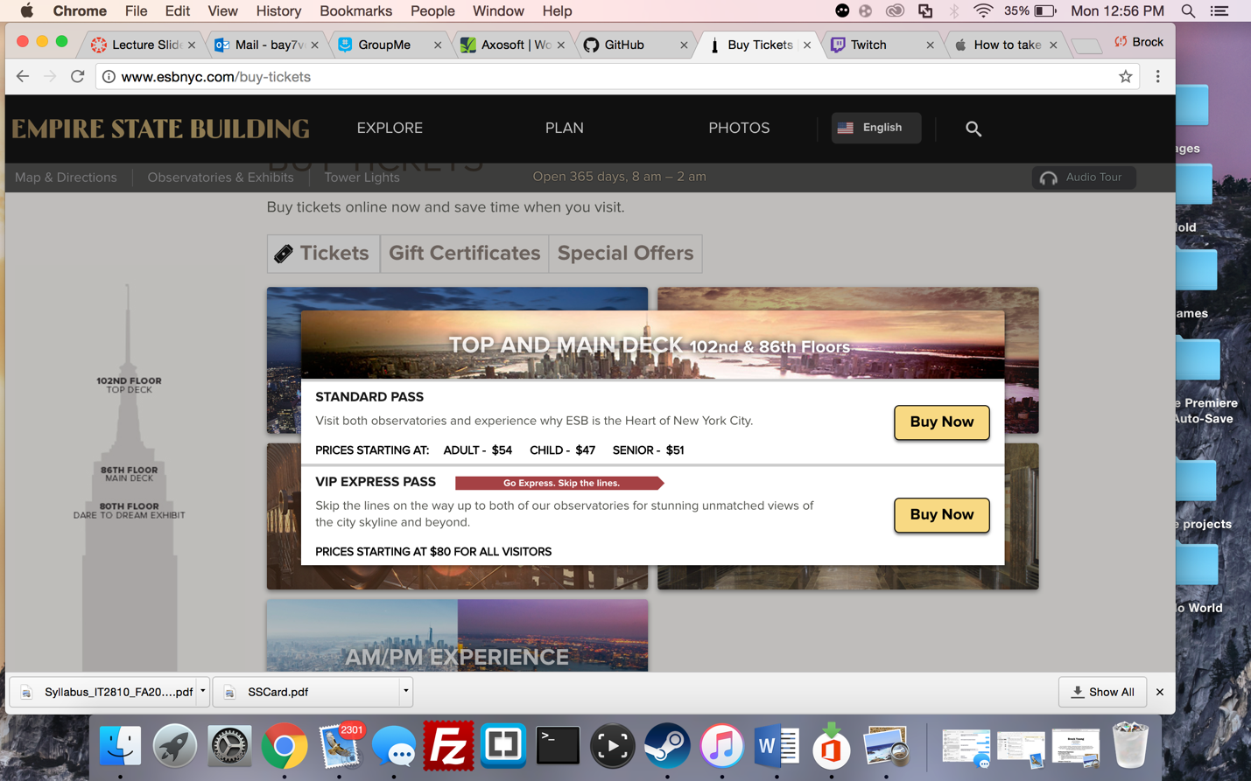

National September 11th Memorial and Museum: